

Rizvi College of Engineering

Department of Computer Engineering

Project Synopsis Report

on

**Dynamic Player Profiling: The Future of Sports and Analytics**

Submitted in partial fulfilment of the requirements

of the degree of

Bachelors of Engineering

by

Shaikh Mohd Shoeb – (201P029)

Katheem Kizhar Ahmed – (201P036)

Chaitanya Vijay Parab – (201P022)

Sayed Amman Akhtar – (201P016)

Guide:

Prof. Mohammed Juned



University of Mumbai

2023 - 2024

**ABSTRACT**

Computer vision technology is revolutionizing sports experience by calculating ball possession, generating heat maps, segmenting team colors, and analyzing player performance. However, occlusions during football matches are a significant challenge for accurate tracking. A robust solution is required to handle occlusion scenarios effectively to determine player and ball positions precisely, essential for generating accurate heatmaps and team analysis.

Keywords:-Computer Vision, Sports Experience, Ball Possession, Segmenting Team Colors, Player Performance, Tracking, Heatmaps, Team Analysis, Ball Tracking, Object Detection, Occlusion Handling.

***Certificate***

This is to certify that the project synopsis entitled “**Dynamic Player Profiling: The Future of Sports and Analytics**” has been submitted by **Shaikh Mohd Shoeb, Katheem Kizhar Ahmed, Chaitanya Vijay Parab, Sayed Amman Akhtar** under the guidance of **Prof. Mohammed Juned** in partial fulfillment of the requirement for the award of the Degree of Bachelor of Engineering in Computer Engineering from Rizvi College of Engineering, University of Mumbai.

Certified By

Prof. Shiburaj Pappu

Dean

Prof. Mohammed Juned Shaikh Prof. Anupam Choudhary

Project Guide Head of Department

Prof. ____________ Prof. ______________

Internal Examiner External Examiner

Dr. Varsha Shah

Principal



Department of Computer Engineering

**Rizvi College of Engineering,**

Off Carter Road, Bandra(W), Mumbai-400050

Declaration

I declare that this written submission represents my ideas in my own words and where others' ideas or words have been included, I have adequately cited and referenced the original sources. I also declare that I have adhered to all principles of academic honesty and integrity and have not misrepresented or fabricated or falsified any idea/data/fact/source in my submission. I understand that any violation of the above will be cause for disciplinary action by the Institute and can also evoke penal action from the sources which have thus not been properly cited or from whom proper permission has not been taken when needed.

-----------------------------------------

(Signature)

Shaikh Mohd Shoeb - 48

Katheem Kizhar Ahmed -11

Chaitanya Vijay Parab - 30

Sayed Amman Akhtar - 37

Date:

**Index**

**Sr. Title Page**

**No No**

1. Introduction 6

2. Literature Survey 7

2.1. Paper I 7

2.2. Paper II 9

3. Proposed System 11

4. Implementation Plan & Output 14

4.1. Output 14

4.2 Gantt Chart 15

5. Conclusion 16

6. References 17

Acknowledgement 18

**Chapter 1**

**Introduction**

In the ever-evolving landscape of sports technology, computer vision is rapidly reshaping the way we experience and analyze athletic events. This cutting-edge technology has the remarkable capability to calculate ball possession, generate intricate heat maps, segment team colors, and scrutinize player performance, thereby providing a deeper insight into the dynamics of sports like football. However, amid the thrilling chaos of a football match, a significant challenge looms large occlusions. These obstructed views, often caused by players and other objects, pose a formidable hurdle to precise tracking, a fundamental element for generating accurate heatmaps and conducting comprehensive team analysis. To overcome this challenge, a robust solution is imperative, one that can effectively handle occlusion scenarios and deliver pinpoint accuracy in determining player and ball positions. This precision is not merely a technological triumph; it is the linchpin to unlocking the full potential of sports analytics in the digital age.

**Chapter 2**

**Literature Survey**

**2.1 Paper I**

**A Study on Sports Player Tracking based on Video using Deep Learning.**

**Sr No**. 10.1109/ICTC49870.2020.9289223

**Year -** DEC 2020

**Summary** **-** Tracking the players in the gasme is essential for the correct evaluation of the players. In order to obtain evaluation indicators for players, such as the moving distance and average speed during a game, it is necessary to continuously track the location and trajectory of the player. The players' movement and events' analysis in the games are mainly recorded by professional analysts. To compensate for this, some sports fields use image processing tools for player tracking and event analysis. In this paper, we study the method that shows excellent performance in the detection and tracking objects recently using deep learning, and discuss how to apply it to sports field.

**Gap Identification -** The paper titled "A Study on Sports Player Tracking based on Video using Deep Learning" authored by JungSoo Lee, Jiwon Lee, Sungwon Moon, Ah Reum Oh, Do-Won Nam, and Wonyoung Yoo, affiliated with the Telecommunications Media Research Laboratory (ETRI) in Daejoen, Korea, presents a deep learning-based approach to address the challenges of tracking sports players in fast-paced and irregular outdoor games. The study explores the application of deep learning techniques for player tracking and discusses the limitations of existing image processing algorithms. Through experimental results, the authors demonstrate the significant improvement in player tracking accuracy after additional learning, particularly in the context of American football and soccer. The paper also outlines future research directions to further enhance tracking success rates, potentially incorporating GPS-based location tracking.

Fig 1: SUMMARY OF DETECTION AND TRACKING SUCCESS

**2.2 Paper II**

**Recognition of the Basketball Players Position Using Live Cameras**

**Sr. No.** 10.1109/ElConRus51938.2021.9396214

**Year -** April 2021

**Summary -** This article discusses the research aimed at creating a program that will track the players of the attacking basketball team in various matches and transfer them to a minimap in the form of dots, showing the trajectory of each player's movement. The article also reviews previous research on this topic, which partially solve the tasks set, and describes the technologies used in this study. Models of previous works have been changed for this research. An experiment was presented that shows the trainability of the neural network that determines the players on the field. The article also describes a ball tracking experiment based on the trainability of neural networks. A study on transferring tracked data (players, ball) to a 2D diagram of a basketball field was conducted.

**Gap Identification -** The paper titled "Recognition of the Basketball Players Position Using Live Cameras" by Egor F. Smirnov, Ivan Yu. Khramov, Nikita S. Ivanov, Viсtoria V. Chernyshova, and Maksim Zavgorodnii explores the development of a program for tracking basketball players' positions during matches using live camera feeds. The research aims to provide a visual representation of player movements on the basketball court, facilitating analysis by coaches, players, and sports analysts. The paper discusses the technologies and methods used for player recognition, including the utilization of neural networks, the Mask-RCNN architecture, and object detection. It also addresses challenges such as camera movements and scoreboard interference. The study presents the results of the model's training, emphasizing the need for larger datasets and more training epochs for improved accuracy. While the paper provides valuable insights into player tracking in basketball games, it highlights technical limitations and suggests avenues for future research and improvements.

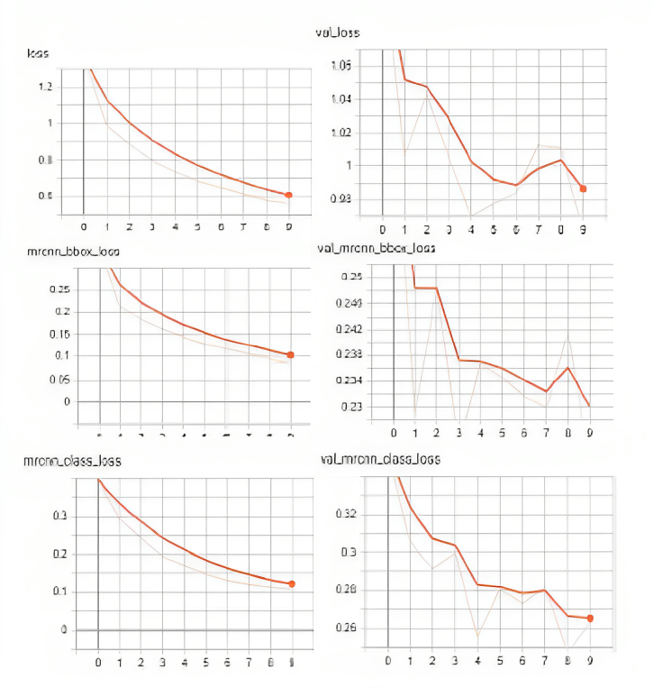

Fig 2. Metrics after 10 epochs.

* Mrcnn_bbox_loss – loss for model Mask R-CNN bounding box refinement.
* val_mrcnn_bbox_loss – val_mrcnn_bbox_loss – a metric that shows how well the model localizes objects(in the test sample).
* mrcnn_class_loss – loss for the classifier head of model Mask R-CNN.
* Val_mrcnn_class_loss – loss for the classifier head of model Mask R-CNN

Based on the trend of the graphs shown in the figures, it can be assumed that this model can be trained better, for which it is necessary to continue the training cycle. But the technical capabilities did not allow us to do this in the framework of this study.

**Chapter 3**

**Proposed System**

**Analysis/Framework/Algorithm:** The foundation of this analysis lies in the integration of computer vision algorithms, primarily utilizing YOLOv8n in the PyTorch framework for object detection and tracking. This framework enables real-time processing of football match video data to determine player and ball positions accurately, despite occlusion scenarios.

**Details of Hardware & Software:** The system relies on a robust hardware setup equipped with high-resolution cameras maintaining a fixed, top-down angle for capturing football matches. The software stack includes Python for programming, OpenCV for computer vision tasks, PyTorch for deep learning, and YOLOv8 for object detection and tracking.

**Design Details:** The design emphasizes a systematic approach to address occlusions during football matches. The cameras are strategically positioned to provide a wide and clear view of the playing field. The system is designed to detect and track players and the ball, ensuring that jerseys are distinguishable with clear colors and numbers, while maintaining a consistent top-down angle for accurate tracking.

**Methodology:** The adopted approach involves a comprehensive development life cycle, beginning with data collection from football matches. This is followed by model selection, transfer learning, integration of tracking algorithms, training, and validation of the system. The final implementation ensures real-time tracking and in-depth data analysis to provide insights into player performance and team strategies.

Fig 3 Football Match Data Analysis Methodology Step-by-Step

**Relevance to PO and PSO of the Department**

**Relevance to PO (Out of 3):**

|  |  |
| --- | --- |
| Engineering knowledge | 3 |
| Problem analysis | 3 |
| Design/development of solutions | 3 |
| Conduct investigations of complex problems | 2 |
| Modern tool usage | 3 |
| The engineer and society | 2 |
| Environment and sustainability | 2 |
| Ethics | 3 |
| Individual and team work | 3 |
| Communication | 3 |
| Project management and finance | 3 |
| Life-long learning | 3 |

**Relevance to PSO (Out of 3):**

|  |  |
| --- | --- |
| Open Source Tools | 3 |
| Industry Readiness | 3 |

**Flowchart:**

Fig 4. Football Match Data Analysis

**Chapter 4**

**4.1 Output:**

**Before Fine Tuning**

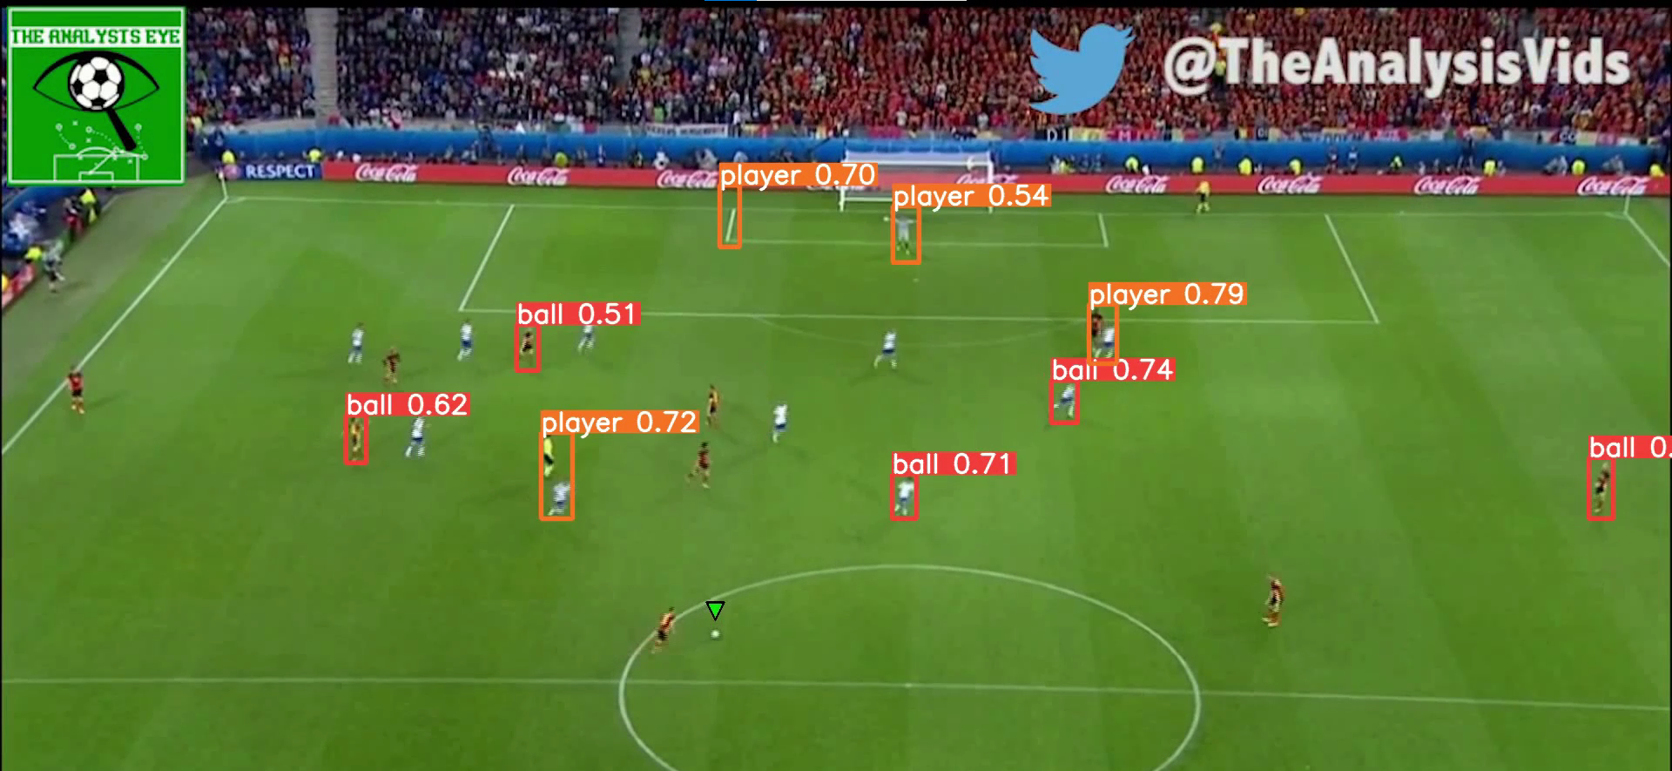

**After Fine Tuning Data Augmentation NMS**

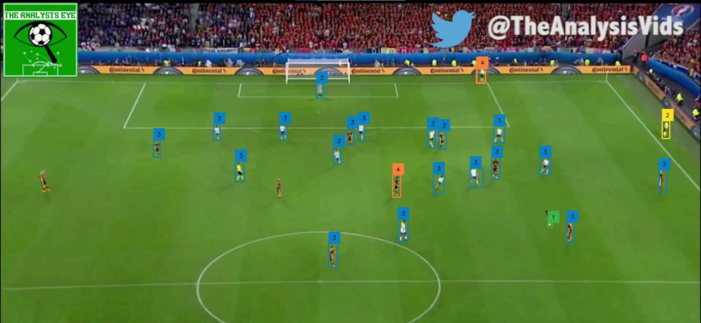

**Even Worked On Different Camera Angles**

**4.2 Gantt Chart:**

**Chapter 5**

**Conclusions**

In conclusion, the Football Tracking System is a game-changer in the fusion of computer vision and sports analytics. By conquering occlusion challenges, it offers a significant advantage to football teams and analysts, as well as an enhanced sports experience for fans. The system's contribution to precision in player and ball tracking, real-time alerts, and comprehensive data analysis underscores its potential to reshape the landscape of football analysis. It not only enhances performance evaluation but also aids in strategic decision-making, making it an indispensable tool in the modern world of football.

Top of Form

**Chapter 6**

**References**

1. Ryan Won, “Traking and Classifying NBA Players in Basketball Video Clips.” Unpublished
2. Ball Tracking and Shot Location Estimation Available at: https://github.com/nuwandda/ball-tracking (accessed 29 November 2020)
3. Erčulj, F., Dežman, B., Vučković, G., Perš, J., Perše, M., & Kristan, M. (2008). An Analysis of Basketball Players ’ Movements in the Slovenian Basketball League Play-Offs Using the Sagit Tracking System. Physical Education and Spor, 6(1).
4. Yoon, Y., Hwang, H., Choi, Y., Joo, M., Oh, H., Park, I., Lee, K. H., & Hwang, J. H. (2019). Analyzing Basketball Movements and Pass Relationships Using Realtime Object Tracking Techniques Based on Deep Learning. IEEE Access, 7. <https://doi.org/10.1109/ACCESS.2019.2913953>
5. Abdulla, W. (2017). Mask R-CNN for object detection and instance segmentation on Keras and TensorFlow. In GitHub repository. Github.
6. Wang, X., Ablavsky, V., Shitrit, H. Ben, & Fua, P. (2014). Take your eyes off the ball: Improving ball-tracking by focusing on team play. Computer Vision and Image Understanding, 119. https://doi.org/10.1016/j.cviu.2013.11.010
7. Yan, F., Christmas, W., & Kittler, J. (2005). A tennis ball tracking algorithm for automatic annotation of tennis match. BMVC 2005 - Proceedings of the British Machine Vision Conference 2005. <https://doi.org/10.5244/C.19.67>
8. Abadi, M., Agarwal, A., Barham, P., Brevdo, E., Chen, Z., Citro, C., Corrado, G. S., Davis, A., Dean, J., Devin, M., Ghemawat, S., Goodfellow, I., Harp, A., Irving, G., Isard, M., Jia, Y., Jozefowicz, R., Kaiser, L., Kudlur, M., … Research, G. (n.d.). TensorFlow: Large-Scale Machine Learning on Heterogeneous Distributed Systems. [www.tensorflow.org](http://www.tensorflow.org).
9. Bradski, G. (2000). The OpenCV Library. Dr. Dobb’s Journal of Software Tools.

**Acknowledgements**

We are profoundly grateful to Prof. MOHAMMED JUNED for his expert guidance and continuous encouragement throughout to see that this project rights its target.

We would like to express deepest appreciation towards Dr. Varsha Shah, Principal RCOE,Mumbai, Prof. ANUPAM CHOUDHARY HOD and Prof. SHIBURAJ PAPPU DEAN of COMPUTER Department whose invaluable guidance supported me in this project.

At last I must express my sincere heartfelt gratitude to all the staff members of Computer Engineering Department who helped us directly or indirectly during this course of work.

Shaikh Mohd Shoeb - 48

Katheem Kizhar Ahmed -11

Chaitanya Vijay Parab - 30

Sayed Amman Akhtar - 37